From descriptions to visual features: Investigating how the world looks during derealization
Authors: Mario Zarco, Keisuke Suzuki, Natsu Sawada
Affiliations: [TO COMPLETE]
[TO COMPLETE] – Information still needed.

Abstract
Derealization is characterised by a sense of detachment from the external world, often accompanied by descriptions of the surroundings using figurative language. However, whether these descriptions correspond to specific visual properties remains unclear. Previous experimental research has primarily examined how real manipulated images appear or how they compare with everyday visual experience, rather than how the surroundings appeared during a particular episode of derealization. In the present study, we aim to investigate whether two measurable visual properties, local contrast and colour saturation, capture aspects of these experiences. We identified these properties through a computational analysis linking descriptions of derealization in the scientific literature to visual features of scene photographs. We propose an online image-choice experiment in which individuals who report having experienced derealization will select between edited versions of photographs according to which more closely resembles how their surroundings looked during a specific episode. A comparison group without reported derealization experiences will make the same choices based on how they believe the surroundings look during derealization. We will test whether individuals reporting derealization preferentially select images with reduced contrast or saturation, and whether these preferences are stronger than those of the comparison group. By linking descriptions of derealization to measurable image properties, this study aims to clarify the relationship between visual descriptions and the reported appearance of the external world during derealization.

1. Introduction

1.1 Derealization and its visual descriptions
Derealization involves an experience of one's surroundings as unreal, strange, or detached, as though one were cut off from the external world (American Psychiatric Association, 2013). It frequently co-occurs with depersonalization, in which the self is experienced as unreal; consequently, most inventories assess the two phenomena together. Transient experiences are common in the general population, whereas depersonalization/derealization disorder is estimated to affect approximately 1–2% (Hunter et al., 2004).
People who have experienced derealization describe the appearance of their surroundings in diverse ways. First-person descriptions appear in qualitative and phenomenological interviews (Ciaunica et al., 2022; Pienkos & Sass, 2022; Fino et al., 2024), historical and contemporary case reports (Sierra & Berrios, 2001; Simeon & Abugel, 2023), conceptual and philosophical analyses of patients' reports (Radovic & Radovic, 2002; Tanaka, 2018; Miyazono, 2021), and posts in online support forums (Dilkes, 2024). Across these sources, surroundings are described as unreal, fake, or artificial; dreamlike; resembling a film, picture, stage set, simulation, or video game; separated from the observer by a veil, pane of glass, or bubble; foggy, blurred, or hazy; flat; dull, faded, or colourless; or lifeless and empty. Because many accounts use comparisons such as 'as if' or 'like', the extent to which these expressions refer literally to visual appearance remains debated (Radovic & Radovic, 2002; Miyazono, 2021; Dilkes, 2024).
Edited images have also been used to investigate derealization, although studies have taken different approaches and reached different conclusions. Yokokawa et al. (2018) manipulated colour saturation both directly and through visual adaptation, such that the same image appeared faded after adaptation to a highly saturated version and more vivid after adaptation to a weakly saturated version. Participants rated the apparent reality of the images, and faded-looking images received lower reality ratings, even when they were physically identical. The authors argued that perceived fadedness may contribute to feelings of unreality and, drawing on neuroimaging findings, proposed a dopamine-dependent frontoparietal mechanism. Kusztor et al. (2025) manipulated saturation and contrast as components of vividness. Participants either rated image reality relative to everyday experience or adjusted saturation and contrast to match their everyday visual experience. Although departures from the images' original vividness reduced reality ratings, derealization symptoms did not affect ratings or adjustments. The authors interpreted reports of altered vividness as metacognitive rather than perceptual. Thus, both studies examined relationships between visual vividness and perceived reality or everyday visual appearance; neither asked participants to match images to the appearance of their surroundings during a particular episode.
The present study addresses this distinction by asking which of two images more closely resembles the appearance of the surroundings during a specific episode of derealization, rather than assessing image reality or everyday visual appearance. Section 1.2 provides an overview of the study, followed by a detailed description of the methods, planned analyses, and sample-size considerations in Sections 2–4.

1.2 The present study
We selected visual features similar to those examined by Kusztor et al. (2025), but through a data-driven procedure described in Supplementary S1. Phrases describing the surroundings during derealization were extracted from selected scientific literature and used to construct semantic axes in the joint image–text space of a CLIP model (Radford et al., 2021). We scored more than one million Places365 scene photographs (Zhou et al., 2018) on these axes and examined their associations with twelve measured image features within scene categories. Two axes informed the present experiment: fog ('fog, blurry, hazy') and vividless ('dull, less vivid, colorless'). Both were associated with local contrast and saturation, but the relative associations differed: local contrast was more closely associated with fog than with vividless, whereas saturation was more closely associated with vividless than with fog (Supplementary S1).. We therefore selected local contrast and saturation as the experimental manipulations.
Participants will be recruited from respondents to an earlier online survey using the Japanese Cambridge Depersonalisation Scale (CDS-29; Sierra & Berrios, 2000; Sugiura et al., 2009). A follow-up questionnaire will establish whether respondents have experienced an episode in which they or their surroundings felt different from usual. Those reporting at least one recognisable episode will form the report group and will be interviewed before the image-choice task; those reporting no such episode will form the comparison group and will not be interviewed.
The experiment will be conducted online. Report-group participants will focus on a specific episode, preferably a recent one that they recall clearly. On each trial, they will choose between two versions of the same photograph, differing in local contrast, saturation, or both, according to which more closely resembles the appearance of their surroundings during that episode. Comparison-group participants will complete the same image-choice task according to their expectations of how the surroundings appear to someone experiencing derealization. The session will also include word ratings and two short blocks in which participants select among multiple versions of a scene.
We will test three hypotheses. H1 predicts that report-group participants will select lower-contrast images when contrast differs between otherwise comparable versions of a scene. H2 predicts a preference for less saturated images when saturation differs. C1 predicts that these preferences will be stronger in the report group than in the comparison group. Together, these hypotheses examine whether the reported appearance of derealization can be related to specific visual features, while recognising that such associations would not establish whether visual perception itself changed during an episode or whether the descriptions reflect an alteration in the felt reality of the surroundings.
The following section describes the study design and procedures in greater detail.

2. Methods

2.1 Participants
Participants will be recruited from a previous online survey of 197 respondents who completed the Japanese Cambridge Depersonalisation Scale (CDS-29; Sierra & Berrios, 2000; Sugiura et al., 2009). The survey was conducted within the six months preceding this study [TO COMPLETE: dates of the survey, platform, how respondents were recruited, and their consent to be contacted again].
Each of the 29 CDS items is rated for frequency over the preceding six months (0–4) and typical duration (1–6, or 0 if frequency is 0). Item scores are calculated by summing these two ratings, and the total CDS score is the sum across all 29 items. We calculate the Alienation from Surroundings factor (AfS; Sierra et al., 2005) from the scores for items 2, 13, 19, and 29.
All respondents will receive a brief follow-up questionnaire, open for four weeks; data collection begins when it is distributed. Respondents will indicate whether they have ever experienced feeling that they or the world around them differed from usual in a way that was difficult to describe (Yes, Not sure, or No). Additional questions address what felt different (including 'the world around you'), the timing, duration, and frequency of these experiences, and willingness to be contacted. The questionnaire also asks whether respondents have ever received a diagnosis at a psychiatric or psychosomatic medicine clinic. Response options include depression or another mood disorder, anxiety disorders (such as panic disorder or social anxiety disorder), post-traumatic stress disorder (PTSD), no previous diagnosis, a preference not to answer, and an open-ended option for other diagnoses. Respondents may select more than one option.
Responses to this questionnaire will determine group eligibility. The report group will comprise respondents reporting at least one recognisable episode of derealization; the comparison group will comprise those reporting no such episode. Throughout the manuscript, 'participants' refers to everyone completing the task in either group.
An additional eligibility criterion applies to both groups: respondents must report no previous psychiatric diagnosis. Only respondents who select 'I have never received a diagnosis' without selecting any other response option are eligible. Respondents who report a diagnosis, decline to disclose their diagnostic history, or provide conflicting responses are not eligible. This criterion reduces confounding by co-occurring conditions and their treatment, such as effects of mood or medication on image preferences.
A respondent is eligible for the report group if they:
- answer Yes or Not sure to having had such an experience;
- give an interpretable answer to how long it lasted (not an episode that occurred only while falling asleep, or under alcohol or medication);
- are willing to be contacted.
All report-group participants will be interviewed about their experiences before completing the task [TO COMPLETE: interview format and approximate length; conducted by a trained research assistant]. The interview content and codebook are outside the scope of this preregistration. Interviews will be coded before task completion, and the task will not refer to interview responses.
Eligible respondents will be invited according to priority tiers defined by endorsement of 'the world around you' and the AfS score. Tier A includes those endorsing this response with AfS ≥ 6; Tier B includes those endorsing it with AfS < 6; and Tier C includes those with AfS ≥ 6 who did not endorse it. Within each tier, more recent episodes receive priority, with episode frequency used to break ties. The tiers determine invitation order. No fixed number of participants is allocated to any tier.
Respondents with a high CDS total but little or no AfS endorsement (CDS total ≥ 70 and AfS ≤ 2; Tier D) will serve as contrast cases in the interviews. If they complete the task, their results will be reported separately and excluded from the sample sizes for H1, H2, and C1.
A respondent is a candidate for the comparison group if they:
- answer No to having had such an experience ("Not sure" is excluded);
- are willing to be contacted;
- have AfS = 0, that is, none of CDS items 2, 13, 19 and 29 endorsed at all;
- have a CDS total of 20 or below. This cut-off was fixed before registration; it is the median total among the 75 respondents with AfS = 0. It leaves 39 candidates.
All comparison-group candidates meeting the questionnaire criteria will be invited; they will not be interviewed. If fewer than 20 complete the task, we will invite a reserve group with AfS = 0 and CDS totals of 21–35 (23 respondents). Reserve-group participants will be analysed with the other comparison-group participants, and their number will be reported.
Recruitment to the report group will stop when 20 analysable participants have been obtained or when all eligible candidates have completed the task, declined, or failed to respond after a reminder, whichever occurs first. Analysability is defined in Section 2.7. The same stopping procedure applies to the comparison group, with a maximum of 30 analysable participants. If more than 20 report-group or 30 comparison-group participants complete the task because sessions finish at approximately the same time, only the first 20 or 30, ordered by completion time, will be analysed; the others will be listed separately. Section 4 explains the sample-size rationale.
The study was approved by [TO COMPLETE: ethics committee and approval number]. [TO COMPLETE: compensation]

2.2 Stimuli
The stimulus set comprises 47 scene photographs from Places365 (Zhou et al., 2018), selected from a corpus of 209,119 colour photographs spanning 82 everyday scene categories. A random sample of 20,000 photographs from this corpus was measured using the same procedure as the experimental stimuli. This reference sample provided the feature percentiles used to calibrate the manipulations and the standard deviations (SDs) used to express feature differences in comparable corpus-based units.
Candidate scenes were selected to have relatively typical values on the fog and vividless axes and on the two manipulated features, avoiding photographs that already appeared unusually foggy or faded. Specifically, their scores on the CLIP-derived fog and vividless axes had to fall between the 35th and 65th percentiles of the corresponding corpus distributions, while their measured local contrast and saturation had to fall between the 30th and 75th percentiles (Supplementary S1). Candidate scenes also had to support every pair type in the trial list (Section 2.3). A shortlist was then screened manually for recognisability, absence of people and animals, familiarity of the setting, variation in lighting, and coverage of indoor and outdoor environments. The 47 selected scenes represent 37 categories (22 indoor, 22 outdoor, and three ambiguous). Each stimulus was generated from the central 512-pixel square of its source photograph.
Each photograph was edited by manipulating colour saturation and local contrast, separately or in combination:
- Saturation. We adjusted the intensity of the image’s colours by scaling chroma (colour intensity) in CIELAB colour space while keeping lightness constant. To increase saturation beyond the original level, chroma was increased gradually towards the maximum colour intensity that could be represented without clipping.
- Local contrast. We reduced the visibility of fine details and edges by blending each photograph towards a uniform colour derived from its brightest 1% of pixels (airlight), producing a haze-like appearance. We then restored the image’s mean luminance to its original level so that the manipulation did not simply change overall brightness. This procedure also reduces colour saturation: at the original saturation level, the reduction in saturation is approximately two-thirds of the reduction in local contrast when both are expressed in corpus-SD units. Pair construction was designed to limit this overlap, particularly by matching measured saturation in contrast-only trials (Section 2.3).
Edit levels were calibrated using percentiles of the measured image features rather than the manipulation parameters. For example, p25 denotes a version whose measured saturation or local contrast reaches the 25th percentile of the reference corpus. Figure 1 illustrates the levels for one scene per feature. The unedited photograph, with its original saturation and local contrast, is not presented in the pair trials. Thus, participants cannot simply discriminate edited from unedited images. The original is, however, included in the grid blocks (Section 2.5).
Features were measured on every edited image using the same methods as for the reference corpus. Saturation is the mean HSV saturation (0–255). Local contrast is the standard deviation of the Laplacian of the greyscale image (0–255 grey-level scale), reflecting local edges and fine detail. HSV saturation was retained as the measured feature because it was associated with the derealization axes in the corpus analysis (Supplementary S1). All subsequent analyses use the measured image features, not the underlying manipulation settings.
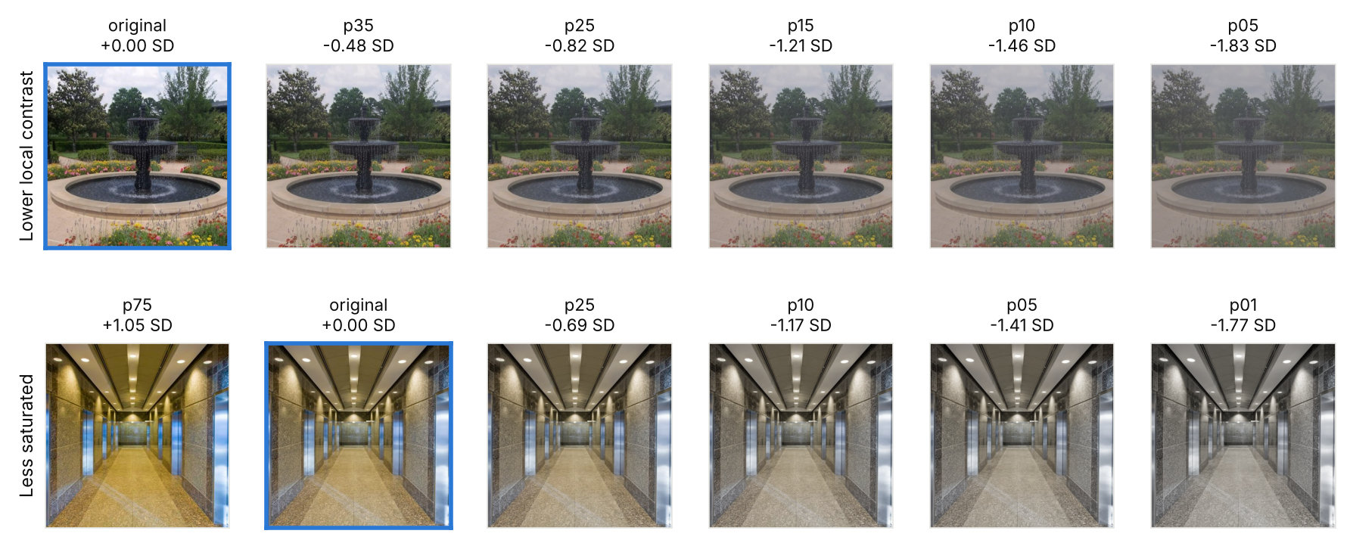
Figure 1. Stimuli at each level, as shown on the grid screens. Top: one scene at its original local contrast and at the five contrast levels. Bottom: one scene at the saturation levels used on the grid, from one level above the original to the lowest. Each image is labelled with its level and its change from the original in the edited feature, in corpus SD. The pair trials use the same levels, without the untouched photograph and with a second level above the original saturation.

2.3 Trial design
Each trial presents two edited versions of the same photograph. Because both images depict the same scene, differences in scene content are held constant within each comparison, allowing choices to be related to the visual features that differ between the images. The image pairs and their presentation order were selected before registration. All participants will complete the trials in the same order, without randomisation.
Each image pair is characterised by two measured differences: the difference in colour saturation and the difference in local contrast between the images. These differences are expressed in corpus-standard-deviation (SD) units, allowing them to be measured on a common scale across photographs. The predictors are signed so that positive preference weights indicate a tendency to choose images with reduced saturation or local contrast, respectively. The left–right positions of the images are balanced within each trial type to prevent systematic preferences for one side from favouring either feature:
$$x_{sat}=−\frac{Δ_{sat}}{σ_{sat}},x_{con}=−\frac{Δ_{con}}{σ_{con}}$$
Here, Δsat and Δcon denote the measured differences between images A and B (A minus B) in saturation and local contrast, respectively. The corpus SDs are σsat = 39.182 and σcon = 9.348, in the units described in Section 2.2. Normalising each difference by a fixed corpus SD makes the predictor magnitude comparable across scenes and manipulation levels. Across the 180 analysed trials, the predictors show little correlation (r = +0.115; Figure 2).
Expressing feature differences in corpus-SD units means that they are measured relative to how much each feature varies across the 20,000 reference photographs. For example, a saturation difference of 39.182 units corresponds to one corpus SD. The preference weights estimated for each participant describe how strongly differences of this size influence their image choices. A positive weight indicates a tendency to select the version with less of the corresponding feature.
Table 1 summarises the trial types and their purposes. The saturation-only trials were selected to provide relatively large differences in saturation, whereas the contrast-only trials were selected to minimise saturation differences between images. The numerical limits in the table refer to measured saturation on the 0–255 scale. Within each trial type, feature differences span predefined ranges, and left–right image placement is balanced. The unedited photograph does not appear in any trial type.
Trial type | n | How the two versions differ | Purpose
Saturation only | 60 | Same contrast-edit level, with a measured saturation difference of at least 31.1 units | Uses larger saturation differences to improve detection of colour preferences (H2)
Contrast only | 60 | Different contrast-edit levels, with measured saturation differing by no more than 3 units | Tests contrast preferences while minimising differences in saturation (H1)
Together | 30 | One image has both lower contrast and lower saturation | Tests choices when both features favour the same image
Conflict | 30 | One image has lower contrast but higher saturation | Helps distinguish which feature drives the choice when the two features favour opposite images
Analysed | 180
Consistency | 15 | An earlier pair, repeated much later with the sides swapped | Data quality only
Catch | 10 | No images; an instruction to press the up or down arrow key (five of each) | Attention; exclusion at three or more failures
Practice | 6 | Saturation-only, contrast-only and together pairs with small to medium differences | Teaching the keys
Presented | 211
Table 1. Trial types, number of trials, and their purposes. Saturation differences are measured on a scale from 0 (no colour saturation) to 255 (maximum saturation). In saturation-only trials, the two images differ by at least 31.1 points on this scale; in contrast-only trials, their saturation differs by no more than 3 points.
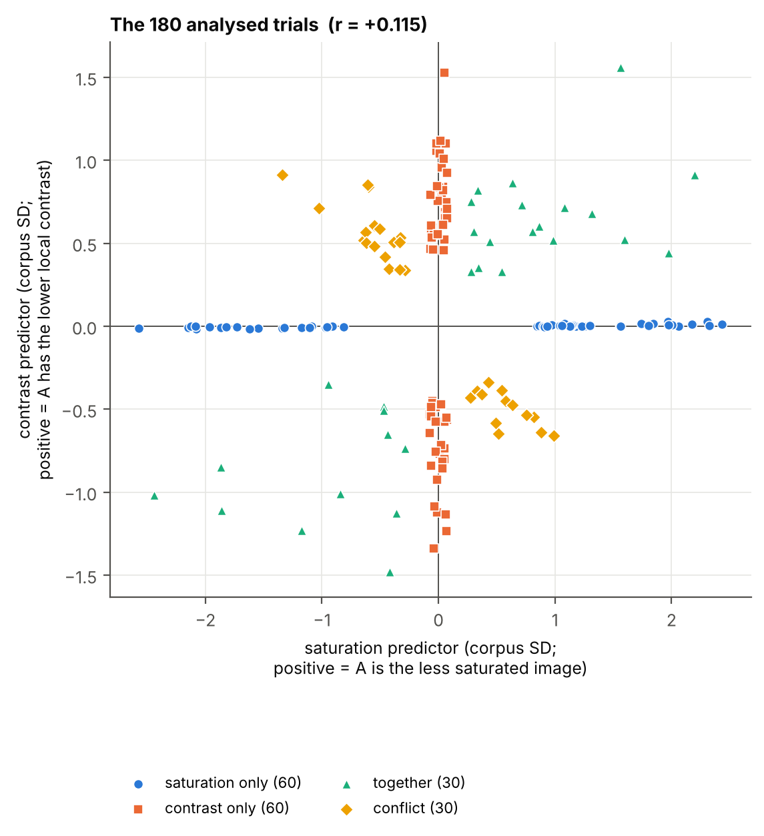
Figure 2. Distribution of the 180 analysed trials across the two predictors. Saturation-only trials lie along the horizontal axis and contrast-only trials along the vertical axis. Together trials have predictors with the same sign, whereas conflict trials have predictors with opposite signs. Positive and negative predictor values indicate which of the two images has the lower value of the corresponding feature. The low correlation between predictors (r = +0.115) facilitates separate estimation of their effects within participants. [TODO: Review the Figure 2 generation script. Revise the figure labels or annotations to explain positive and negative predictor values in terms of differences in saturation and local contrast, rather than relying on internal image labels A and B. Verify that the labels agree with the signed predictors in the trial list. Regenerate the figure and remove this note before submission.]

2.4 Session and task
The online experiment will run in a web browser (jsPsych; de Leeuw et al., 2023) on a desktop or laptop computer with a keyboard, in Japanese. Both groups will complete the same sequence of blocks (Figure 3). Word ratings follow the pair trials to reduce priming of image choices, and the normal-appearance grid is administered last to avoid influencing responses about the episode. Group assignment changes the wording of four elements: the anchoring instructions, the pair-trial question, the episode-grid question, and the word-rating question. The session follows the sequence below.
- Consent [TO COMPLETE: approved consent text]. Declining ends the session, and nothing is uploaded.
- Identification with the participant ID issued at recruitment. Name and email address are optional; if given, they are sent at this screen to a separate private destination and never stored with the responses [TO COMPLETE: confirm that this is stated in the approved consent text].
- Full-screen mode and screen check. Participants will be asked to enter full-screen mode. Pair images are always shown at 512 × 512 CSS pixels, never scaled, because local contrast depends on fine detail. If the window is too small, a warning asks the participant to use a larger screen if possible; the session cannot continue only when the window is narrower than 800 pixels. Whether both pair images fit side by side is recorded for every session.
- Brightness instructions. Participants will be asked to set their screen brightness to maximum and to disable night mode or blue-light and colour filters where possible. Adherence will not be verified.
- Gamma matching. Participants will complete three repetitions of a split-field luminance-matching task (Roca-Vila et al., 2013 [to verify reference]), adjusting the luminance of a grey patch to match a fine black-and-white checkerboard. The median setting will provide an estimate of display gamma, the relationship between image pixel values and displayed luminance. This procedure takes approximately two minutes; the gamma estimate will be recorded as a display covariate.
- Anchoring. The report group reads: "Please bring to mind one specific episode in which your surroundings felt different from usual, ideally a recent one that you remember clearly. Throughout this study, please answer about that episode." An optional box asks for a few words identifying the episode (for example, where they were). The comparison group reads (proposed wording): "Derealization is an experience in which one's surroundings feel strange or detached, as if one were cut off from the world. In this study, please answer according to how you think the surroundings look to someone experiencing derealization." [TO COMPLETE: comparison-group wording]
- Practice (six trials). Feedback will explain the response-key mapping and indicate that there is no correct image choice.
- Pair trials: 205 trials (180 analysed, 15 consistency and 10 catch trials). Each trial shows a fixation cross, then the two images side by side with the question above them, then a short blank screen. The question for the report group is "Which looks more like how your surroundings looked during that episode?"; for the comparison group (proposed wording), it is "Which looks more like how you think the surroundings look to someone experiencing derealization?". Participants answer with the left or right arrow key; there is no time limit, and we record the response time. A break screen appears after every 35 trials (the current setting of the experiment).
- The episode grid: four screens (section 2.5).
- Word ratings. Participants will rate ten words, presented in random order, from 0 to 6 according to how well each describes the appearance of the surroundings during the episode. Comparison-group participants will rate how they believe the surroundings appear during derealization (Table 2).
- The normal-appearance grid: four screens about how the participant's surroundings normally look.
- State items: the four AfS items of the CDS (items 2, 13, 19 and 29), each introduced by "Right now, at this moment:" and rated on the same 0–6 scale, from "not at all" to "completely". The wording is that of the Japanese version of the CDS used in the survey (Sugiura et al., 2009); the time frame and the response scale are an adaptation, because no standard state form of these items exists.
- Upload. Nothing is saved until the end. If the upload fails, the participant can download the data file and send it by email.
The quotations in this section are English versions of the task instructions. Participants will see Japanese translations reviewed by a native speaker; the final wording will be included in the deployed experiment materials (Section 5.2) and fixed before data collection.
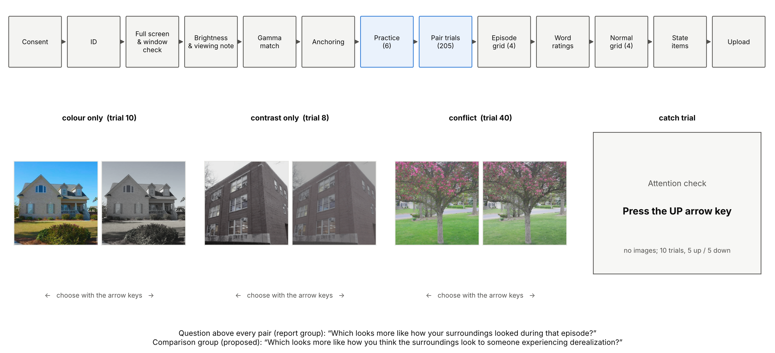
Figure 3. The session. Top: the order of the blocks, the same for both groups. Below: three example pair trials from the fixed trial list (saturation only, contrast only and conflict) and a catch trial, which shows no images. The question appears above every pair.

Role | Words
Targets | foggy; faded
Close to the targets | veiled; lifeless
Derealization baseline | unreal; dreamlike; distant; like a picture
Fillers | oppressive (low mood); threatening (anxiety)
Table 2. Words rated after the grid of the episode block, each on a scale from 0 to 6.
Table 2 distinguishes the target descriptions from related terms, general descriptions of derealization, and filler terms. The ratings are collected after the image-choice trials to avoid introducing these descriptions before participants make their image choices.

2.5 The grid blocks
The grid blocks complement the pair trials by allowing participants to select from a range of saturation and local-contrast levels, rather than choosing between only two images. Comparing selections about derealization with those about ordinary appearance provides an individual reference point for assessing how the two differ.
Two grid blocks will be administered, each consisting of four screens. Each screen presents six levels of one feature in columns and three scenes in rows, reducing reliance on a single photograph. Participants select the column most closely matching the appearance of the surroundings. Contrast screens show the original image and five lower-contrast levels at original saturation; saturation screens show one level above the original, the original, and four lower levels at original contrast. Each feature appears twice per block, with the column order reversed, enabling assessment of position-based responding.
The episode grid follows the pair trials and includes a 'None of these' response option with an optional free-text explanation. The normal-appearance grid follows the word ratings and asks participants to select the column most closely matching how their surroundings usually appear. It does not include 'None of these', because this response would prevent calculation of the episode–normal shift.
The blocks use separate sets of 12 scenes, matched pairwise on original saturation and local contrast, so that no photograph appears in both blocks for the same participant. The assignment of each set to the episode or normal-appearance block is randomised with equal probability at the start of the session and recorded.
Because six 512-pixel images cannot fit side by side on a typical laptop display, grid images will be presented at smaller sizes (100–240 pixels, depending on the window), with a common size within each block. Image size and the device pixel ratio (physical display pixels per CSS pixel) will be recorded.
The grid blocks are descriptive; no registered test uses them (section 3.6).

2.6 Other measures
We also record the following measures:
- the CDS item scores from the survey (items 2, 13, 19 and 29) and the CDS total;
- display measures: the gamma estimate, the device pixel ratio, the window size and the grid cell size;
- the response time on every pair trial.
Display measures will be reported but will not be used to adjust preference weights, because the image features are quantified from the stimulus files rather than from the appearance of stimuli on individual screens.

2.7 Data quality and exclusions
The individual detection thresholds (Section 3) and group-level error rates and power estimates (Section 4) were derived for the 180 analysed trials in the fixed trial list. Consequently, participants will be analysed only if all 180 trials are complete. All trials require a response, and data are saved only at the end of the session. The analysis checks that every completed session contains each of the 211 specified trials exactly once and independently scores catch-trial responses from the recorded key presses.
Sessions will not be included in the analyses if the participant does not provide consent, if the session is incomplete or its data are not successfully uploaded, if the window was too narrow to show both pair images side by side, or if the participant fails three or more of the ten catch trials. These exclusion criteria apply to both groups. Excluded sessions will not count towards the target sample sizes, and recruitment will continue within the available pool of eligible candidates.
Test and development sessions will not be analysed. If a participant completes more than one session, only the first complete session will be analysed, with subsequent submissions reported. Missing supplementary grid, word-rating, or state responses will affect only the corresponding descriptive analysis. Other sampling and reporting rules, including those for Tier D and recruitment limits, are specified in Section 2.1.

3. Analysis plan

3.1 Hypotheses
As introduced in Section 1.2, this study evaluates three hypotheses concerning participants’ choices between edited versions of the same photograph.
H1 (local contrast). When two images of the same scene differ in local contrast but are matched in saturation, report-group participants are expected to select the lower-contrast image as the closer match to the episode. Support for H1 would be consistent with reports of fog or haze being associated with lower contrast in the recalled appearance of the surroundings.
H2 (saturation). When two images of the same scene differ in saturation but are matched in local contrast, report-group participants are expected to select the less saturated image. Support for H2 would be consistent with descriptions of faded or dull surroundings being associated with lower saturation in recalled appearance.
C1 (report group versus comparison group). For each feature, preference weights are expected to be higher in the report group than in the comparison group, whose choices reflect expectations about derealization. Support for C1 would establish a difference between these groups under their respective task instructions, without identifying its underlying cause.

3.2 The per-person model
For each analysable participant, we will fit a Firth bias-reduced logistic regression (Firth, 1993), without an intercept, to the 180 analysed image choices. Two participant-specific weights are estimated: one for local contrast (w_con) and one for saturation (w_sat):
$$P\left(\text{choose image A}\right)=\frac{1}{1+exp\left[−\left(w_{con}x_{con}+w_{sat}x_{sat}\right)\right]}$$
A positive weight indicates a tendency to select lower-contrast or less saturated images, and its magnitude quantifies the influence of that feature on choices. Firth estimation yields finite weights even for participants whose choices are perfectly consistent, for which ordinary logistic regression gives infinite weights. We will report 95% profile penalised-likelihood intervals for both weights. Because the features use different corpus-SD scales, weights will be compared across participants or groups for the same feature, rather than directly across features within a participant.
Each weight will be classified using upper and lower detection thresholds obtained from 20,000 simulated random choosers responding to the fixed trials. The cut-offs correspond to the upper and lower 2.5% tails of the null weight distributions (Table 3).
Weight | Upper threshold (predicted direction) | Lower threshold (opposite direction)
Saturation | +0.286 | −0.290
Local contrast | +0.488 | −0.486
Table 3. Detection thresholds for the two preference weights.
The detection threshold is higher for local contrast than for saturation because the trial pairs provide less information about contrast preferences, making them harder to distinguish from random responding. For each feature, participants will be classified as having a detected preference in the predicted direction (above the upper threshold), a detected preference in the opposite direction (below the lower threshold), or no detected preference.
Figure 4 presents the probability of detecting a participant's preference as a function of its true weight. A 'responder' is a simulated participant whose choices are influenced by a feature. For the sample-size planning scenario, we assumed true weights of 0.50 per corpus SD for saturation and 0.70 for local contrast. These values were not estimated from participants; they were selected to represent similar levels of choice consistency for the two features. Because typical informative trials have larger differences in saturation (approximately 1.0 corpus SD) than in local contrast (approximately 0.64 corpus SD), a larger contrast weight is needed to produce a comparable choice probability. The selected weights correspond to choosing the predicted image on approximately 62% of typical saturation trials and 61% of typical contrast trials, before random lapses. A lapse represents a trial answered at random. At a lapse rate of 0.1, preferences at these planning strengths are detected approximately 85% of the time for saturation and 71% for local contrast.
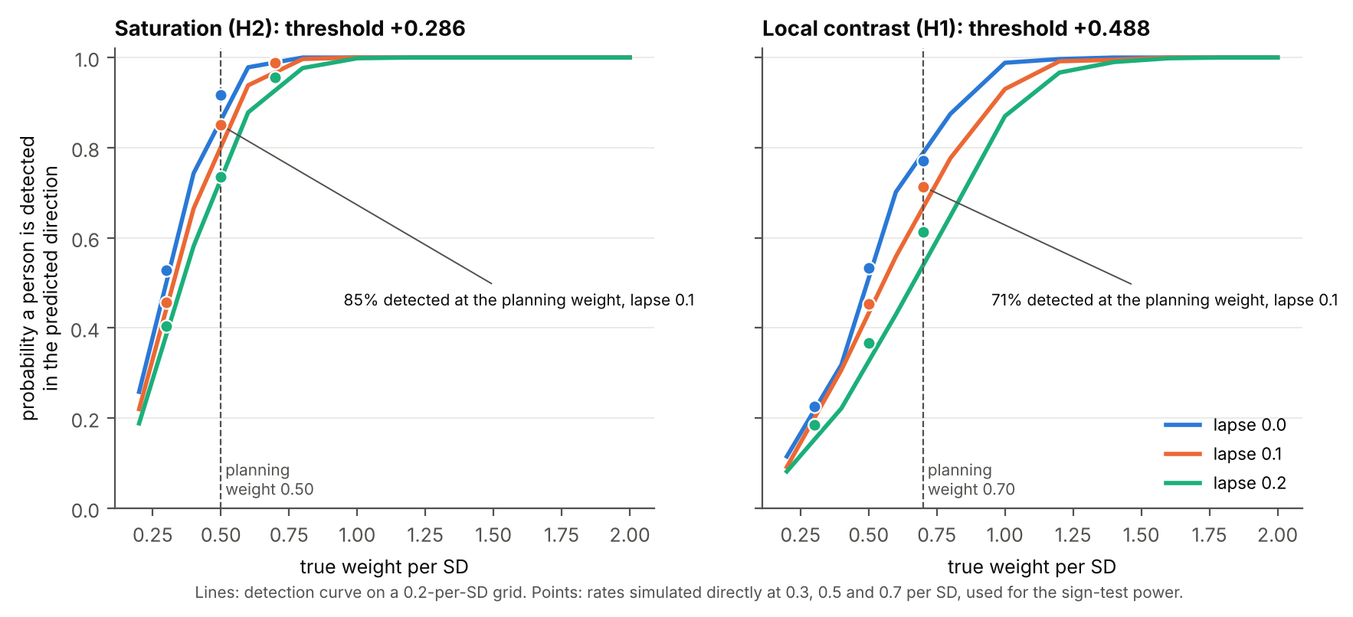
Figure 4. Probability that a participant is detected in the predicted direction, by true weight per corpus SD, at lapse rates of 0, 0.1 and 0.2 (simulated on the fixed trial list). Lines join a grid of true weights 0.2 apart; points are the rates simulated directly at 0.3, 0.5 and 0.7 per corpus SD, which the power calculation of the sign test uses (section 4). Dashed lines mark the planning weights (0.50 for saturation and 0.70 for local contrast), which correspond to choosing the predicted image on about 62% and 61% of typical informative trials.

3.3 H1 and H2: the decision rule
Let N denote the final number of analysable report-group participants, excluding Tier D. For each feature, let d be the number with a detected preference in either direction and a the number detected in the predicted direction. Each hypothesis will be evaluated with a one-sided exact sign test, implemented as a binomial test of a under Binomial(d, 0.5) at α = 0.05. No additional minimum is imposed on a. A hypothesis is supported if its one-sided p-value is ≤ 0.05. H1 and H2 are assessed separately at the 5% level. When N < 10, counts will be reported without a hypothesis verdict.
H1 and H2 concern different visual features and will be tested separately, each at a significance level of 5% (α = 0.05). This conventional threshold means that, if a hypothesis is false and the assumptions of the statistical test are satisfied, the probability of incorrectly supporting it is at most 5%. We will not apply a correction for testing both hypotheses, as they are treated as separate claims about different visual features. Consequently, if neither effect exists, testing both hypotheses creates two opportunities for a false-positive result, and the probability of incorrectly supporting at least one could approach 10%. Thus, the 5% error rate applies to each hypothesis individually, not to the two hypotheses considered together.
The sign test provides false-positive control without simulation-based calibration of a group rule. Under a no-effect model, remembered appearance does not influence choices: individuals may choose at random or according to personal preferences for contrast or saturation. Provided that participants are independent and, conditional on a detected preference, its direction is equally likely to be predicted or opposite, the number a follows Binomial(d, 0.5) conditional on d, irrespective of the overall frequency or strength of detectable preferences.
The 180 analysed trials reuse 47 scenes in a fixed order, making within-person dependence among responses to repeated scenes possible. Such dependence may affect individual threshold calibration, statistical power, and the count-rule sensitivity analysis. It does not invalidate the sign test's conditional false-positive bound if the directions of detected preferences remain independent and symmetric across participants. Scene-related preferences that differ idiosyncratically in direction across individuals may increase detection counts in both directions. A preference shared in the same direction across participants would violate this symmetry assumption; comparisons with the other group may help evaluate, but cannot eliminate, this concern.
The sign test requires consistent evidence across several participants before a hypothesis can be supported. At least five participants must have a detected preference, and when five to seven participants are detected, all must favour the predicted direction (Table 4). This requirement reduces the risk of supporting a hypothesis based on chance preferences. However, it also reduces statistical power in small samples, as examined in Section 4 (Figure 5).

Detected (d) | Predicted needed | Opposite allowed | p at boundary
1–4 | no claim possible | – | ≥ 0.0625
5 | 5 | 0 | 0.031
6 | 6 | 0 | 0.016
7 | 7 | 0 | 0.008
8 | 7 | 1 | 0.035
9 | 8 | 1 | 0.020
10 | 9 | 1 | 0.011
11 | 9 | 2 | 0.033
12 | 10 | 2 | 0.019
13 | 10 | 3 | 0.046
14 | 11 | 3 | 0.029
15 | 12 | 3 | 0.018
16 | 12 | 4 | 0.038
17 | 13 | 4 | 0.025
18 | 13 | 5 | 0.048
19 | 14 | 5 | 0.032
20 | 15 | 5 | 0.021
Table 4. The sign test: the smallest number of detected participants in the predicted direction that supports the claim, for each number detected in either direction, with the exact one-sided p at that boundary.
As a sensitivity analysis, we will also apply the count rule (Table 5): at least k detected preferences in the predicted direction and at most m in the opposite direction. The (k, m) values were selected separately for each N by simulation to keep the estimated false-claim rate at or below 0.05 (based on the upper 95% Monte Carlo confidence limit) under random choice and specified symmetric taste distributions. This rule is more powerful than the sign test at small N under the planning assumptions, but its error control does not extend beyond the evaluated models; rates reach 0.14 under broader null scenarios. Both verdicts will be reported, but only the sign test will determine support for H1 or H2.
N | 10 | 11 | 12 | 13 | 14 | 15 | 16 | 17 | 18 | 19 | 20
Saturation (k, m) | 4, 0 | 5, 2 | 5, 2 | 5, 1 | 5, 1 | 6, 3 | 6, 2 | 6, 2 | 6, 2 | 7, 3 | 7, 3
Local contrast (k, m) | 4, 0 | 5, 2 | 5, 2 | 5, 1 | 5, 1 | 5, 1 | 5, 1 | 5, 1 | 5, 1 | 5, 1 | 5, 1
Table 5. The count rule used as a sensitivity analysis.

3.4 C1: report group against comparison group
C1 compares preferences between the report group and the comparison group. However, if comparison-group participants respond more frequently at random, their estimated preference weights may be weaker, potentially creating an apparent group difference. To address this possibility, we will first compare the groups on two indicators of attention: catch-trial failures and the proportion of very fast responses (below 300 ms). Fast responses are treated as a possible indicator of inattention, not as proof of it or as an individual exclusion criterion. The attention check is one-sided because greater random responding in the comparison group could exaggerate a positive group difference, whereas greater random responding in the report group would tend to reduce it. After applying the catch-trial exclusion criteria and excluding Tier D, C1 will be evaluated using the following three-step procedure.
- Attention check. For each participant, we will calculate the number of catch-trial failures and the proportion of analysed image trials with response times below 300 ms. Each measure will be compared between groups using a one-sided Mann–Whitney test for poorer performance in the comparison group, with Holm correction across the two tests (α = 0.05). If either corrected test is significant, C1 will be classified as inconclusive, irrespective of the restricted comparison among participants with no catch failures.
- Group comparison. For each feature, we will compare report-group and comparison-group preference weights with a one-sided Mann–Whitney test, with Holm correction across the two features (α = 0.05). C1 will be supported for a feature when its multiplicity-adjusted test is significant.
- Sample-size qualification. If fewer than 20 analysable comparison-group participants are available, C1 results will be descriptive only: distributions and test statistics will be reported without a hypothesis verdict.
Thus, a confirmatory C1 verdict requires at least 20 analysable comparison-group participants and no significant attention-gate result. Otherwise, C1 will be descriptive (insufficient controls) or inconclusive (attention gate triggered), as specified above.
The comparison also allows us to examine whether stronger preferences in the report group extend beyond those observed among participants responding according to expectations or a general preference for more heavily edited images. Such preferences may occur in both groups, although their underlying motivations need not be the same (Section 3.7).

3.5 Secondary analysis
For each feature in the report group, we will assess whether the mean preference weight exceeds zero using a one-sided one-sample t-test and a one-sided Jeffreys–Zellner–Siow (JZS) Bayes factor (Cauchy prior on effect size, scale 0.707; Rouder et al., 2009). Bayes factors will be reported continuously and will not determine support for the confirmatory hypotheses.
These analyses will be conducted both with and without a cap on extreme preference weights. That is, by replacing an unusually large positive or negative weight with a predetermined maximum or minimum value. Although Firth regression produces finite estimates, highly consistent participants can receive very large weights that disproportionately influence the group mean. Comparing the results with and without capping allows us to assess whether the findings depend on these extreme values. The cap will be used only in these secondary analyses; it will not alter the primary H1, H2, or C1 analyses.
The caps were determined using simulated responses to the fixed trial list. For each feature, we simulated a participant who consistently selected the predicted image whenever the absolute predictor value for that feature was at least 0.20 corpus SD, while responding at chance level on the remaining trials. Fitting the same Firth regression to these responses yielded cap values of 8.378 for saturation and 10.269 for local contrast. In the capped analysis, estimated weights exceeding these limits in either direction will be replaced by the corresponding positive or negative cap. Participants will not be excluded, and the uncapped results will also be reported.

3.6 Exploratory and descriptive analyses
The following analyses are exploratory or descriptive; their results will be reported with intervals where applicable and will not determine confirmatory claims.
- For each feature, we will estimate the proportion of report-group participants whose choices show a genuine feature-related preference (prevalence). We will first report the number of participants with detected preferences in the predicted and opposite directions. We will then estimate prevalence by comparing these counts and accounting for the possibility that a true preference may go undetected. Because this correction depends on the strength of the preference, we will report estimates under three assumed response strengths (weak, moderate, and strong), corresponding to true weights of 0.30, 0.50, and 0.70 per corpus SD. Estimates will be presented with uncertainty intervals.
- Following the simpler analysis of Suzuki et al. (2024), we will examine the proportion of predicted-direction choices on the 60 saturation-only and 60 contrast-only trials. For each feature, a participant will be classified as following the predicted direction if they choose the corresponding image on at least 39 of 60 trials. This threshold is the smallest count that reaches significance in a two-sided exact binomial test at α = 0.05, assuming a 50% probability of choosing either image by chance. We will also compare the mean proportion of predicted-direction choices across report-group participants with 0.5 using a one-sample t-test.
- We will explore associations between feature preference weights and descriptions of the experience (E1). First, CDS item 13, which describes surroundings as detached or unreal, as if seen through a veil, will be related to the contrast weight; CDS item 2, which describes the visual world as flat or lifeless, like a picture, will be related to the saturation weight. Because item 2 does not refer specifically to colour, this association will not be interpreted as a direct test of saturation [to verify item content against the survey wording]. Second, for each target word (“foggy” and “faded”), we will calculate an adjusted rating by subtracting the participant’s mean rating of the four baseline terms (“unreal”, “dreamlike”, “distant”, and “like a picture”). This adjustment distinguishes endorsement of a particular visual description from general endorsement of derealization-related descriptions. The adjusted ratings of “foggy” and “faded” will be related to the estimated contrast and saturation preference weights, respectively, using Spearman correlations with bootstrap intervals and individual observations. The related terms (“veiled” and “lifeless”) will be examined descriptively to determine whether they receive stronger endorsement than their corresponding target words, while the filler terms (“oppressive” and “threatening”) will help characterise general endorsement of negative descriptions. Because these ratings are collected after the image-choice trials, they may be influenced by participants’ preceding choices. These analyses are exploratory and will not determine support for the confirmatory hypotheses. Participants giving identical ratings to all words will be omitted only from the word-rating correlations. Interview codes will not enter these preregistered analyses; any subsequent use of coded interviews will be labelled exploratory.
- We will quantify the location of the episode-related choice within the manipulated range relative to the participant's normal-appearance choice (E2). For each feature, the difference between blocks will be calculated in corpus SDs as the mean selected-column change from the original across the two screens, episode minus normal appearance. We will also report selections of the original contrast column, for which the range is censored because no higher-contrast alternative is presented; unedited-column selections; 'None of these' responses and associated text; scene-set assignment; and grid-cell size. Extreme-column or 'None of these' responses may indicate that the available stimulus range does not adequately represent the participant's answer.
- Dose–response and additivity will be explored by describing how the proportion of predicted-direction choices varies with feature-difference magnitude and how choices on together and conflict trials reflect the combined manipulations. Results will be reported by trial type and group.
- To assess whether particular scenes disproportionately influence choices, we will report the proportion of predicted-direction responses by scene and group. We will also recompute participant-level weight intervals by resampling trials in scene-level clusters. These descriptive analyses will assess sensitivity to possible within-scene dependence.
- Response quality and potential sources of individual variation will be described using agreement across the 15 repeated pairs (proportion of repeated pairs receiving the same image choice), response times, catch-trial failures, display measures (gamma, device pixel ratio, and grid-cell size), interview-to-task delay, and state items. Low consistency may indicate noisy task performance or unstable recollection and will qualify interpretation.

3.7 Interpretation of the results
The experiment examines how participants match edited images to their recollection of a specific episode of derealization. Because the task is completed after the episode, it does not directly measure how the surroundings were perceived at the time. Two broad interpretations of visual descriptions of derealization are possible: the surroundings may have appeared visually different during the episode, or the main alteration may have concerned the felt reality of the surroundings, with expressions such as “foggy” or “faded” used to describe that experience. These interpretations are not necessarily mutually exclusive.
Support for H1 or H2 would indicate that, among report-group participants with detectable feature-related preferences, the predicted direction occurs more often than expected under the sign test’s assumptions. Such a result would be consistent with the remembered appearance of the surroundings being associated with reduced local contrast or saturation, but would not establish that visual perception itself changed during the episode. Conversely, failure to support either hypothesis would not establish that the corresponding visual change was absent. An effect might be too weak or uncommon to detect, or the remembered appearance might involve visual properties other than those manipulated in this experiment.
C1 provides a comparison with participants who make their choices according to expectations about derealization rather than recollection of an episode. Support for C1 would indicate stronger feature-related preferences in the report group than in the comparison group. However, the groups also differ in recruitment characteristics, task instructions, and prior interview participation. Consequently, a group difference cannot establish that the preference arises specifically from remembered visual perception rather than differences in expectations or other factors. Failure to support C1 would likewise not establish that the groups have equivalent preferences.
The results will be interpreted separately for each feature. Support for H1 or H2 together with the corresponding C1 comparison would indicate a directional preference in the report group together with a group difference. Support for H1 or H2 without C1 would indicate a directional preference without a demonstrated group difference. Support for C1 without the corresponding H1 or H2 would indicate a group difference without sufficient evidence for the predicted direction under the sign test. If neither is supported, the results will not distinguish between the competing interpretations.

4. Sample size and design analysis
The target sample comprises 10–20 analysable report-group participants and 20–30 comparison-group participants. Recruitment is limited to respondents from an earlier survey, and report-group participants must complete an interview before the image-choice task. Of the 197 survey respondents, 58 had Alienation from Surroundings (AfS) scores of at least 6, although eligibility also depends on responses to the follow-up questionnaire, including the absence of a previous psychiatric diagnosis. Accounting for potential refusals and non-response, we anticipate recruiting approximately 10–20 analysable report-group participants. The maximum of 20 also reflects the interview workload. Recruitment will follow the predetermined stopping rules in Section 2.1 and will not depend on the observed experimental results.
Because no image-choice data have yet been collected, statistical power was evaluated under hypothetical scenarios rather than estimated from observed participant effects. Our main planning scenario assumes that half of report-group participants have a genuine feature-related preference, with the number rounded up when the sample size is odd. We assume preference weights of 0.50 per corpus SD for saturation and 0.70 for local contrast, corresponding to choosing the predicted image on approximately 62% and 61% of typical informative trials, respectively. We also assume that 10% of trials are answered randomly. These values are planning assumptions, not estimates of actual participants' behaviour.
We evaluated the planned tests using simulated responses to the fixed trial list. The simulations included participants who chose randomly, participants with personal preferences for image features unrelated to derealization, and participants whose choices were influenced by the hypothesised features. We varied the strength of these preferences and the proportion of randomly answered trials. For personal preferences unrelated to derealization, we considered distributions centred on zero, allowing some individuals to favour lower feature values and others to favour higher values. The spread of these preferences ranged from 0.25 to 1 times the corresponding detection threshold; the main planning scenario used 0.5 times that threshold. For each scenario, we estimated how often individual preferences would be detected in either direction and then calculated how often groups of different sizes would satisfy the sign-test decision rule. This provided estimates of statistical power when genuine responders were present and false-positive probabilities when they were absent.
Figure 5 shows how the probability of supporting H1 or H2 varies with sample size and the proportion of genuine responders. Under the main planning scenario, power for local contrast is approximately 23%, 65%, and 79% at sample sizes of 10, 15, and 20, respectively. The corresponding values for saturation are 40%, 83%, and 92%. Power is lower at small sample sizes because the sign test requires detected preferences in at least five participants before a hypothesis can be supported (Section 3.3). When all participants are assumed to respond, both hypotheses have high power throughout the planned range. In contrast, when only one-quarter respond, power remains below 32%, even at the largest planned sample size.
The count-rule sensitivity analysis has higher power than the sign test under the main planning scenario. However, in some other scenarios without an episode-related effect, the count rule can incorrectly support a hypothesis more than 5% of the time. The sign test therefore remains the confirmatory analysis, while the count rule provides an additional assessment of sensitivity. These results also indicate that failure to support H1 or H2 cannot establish that the corresponding effect is absent, particularly if genuine preferences are weak or uncommon.
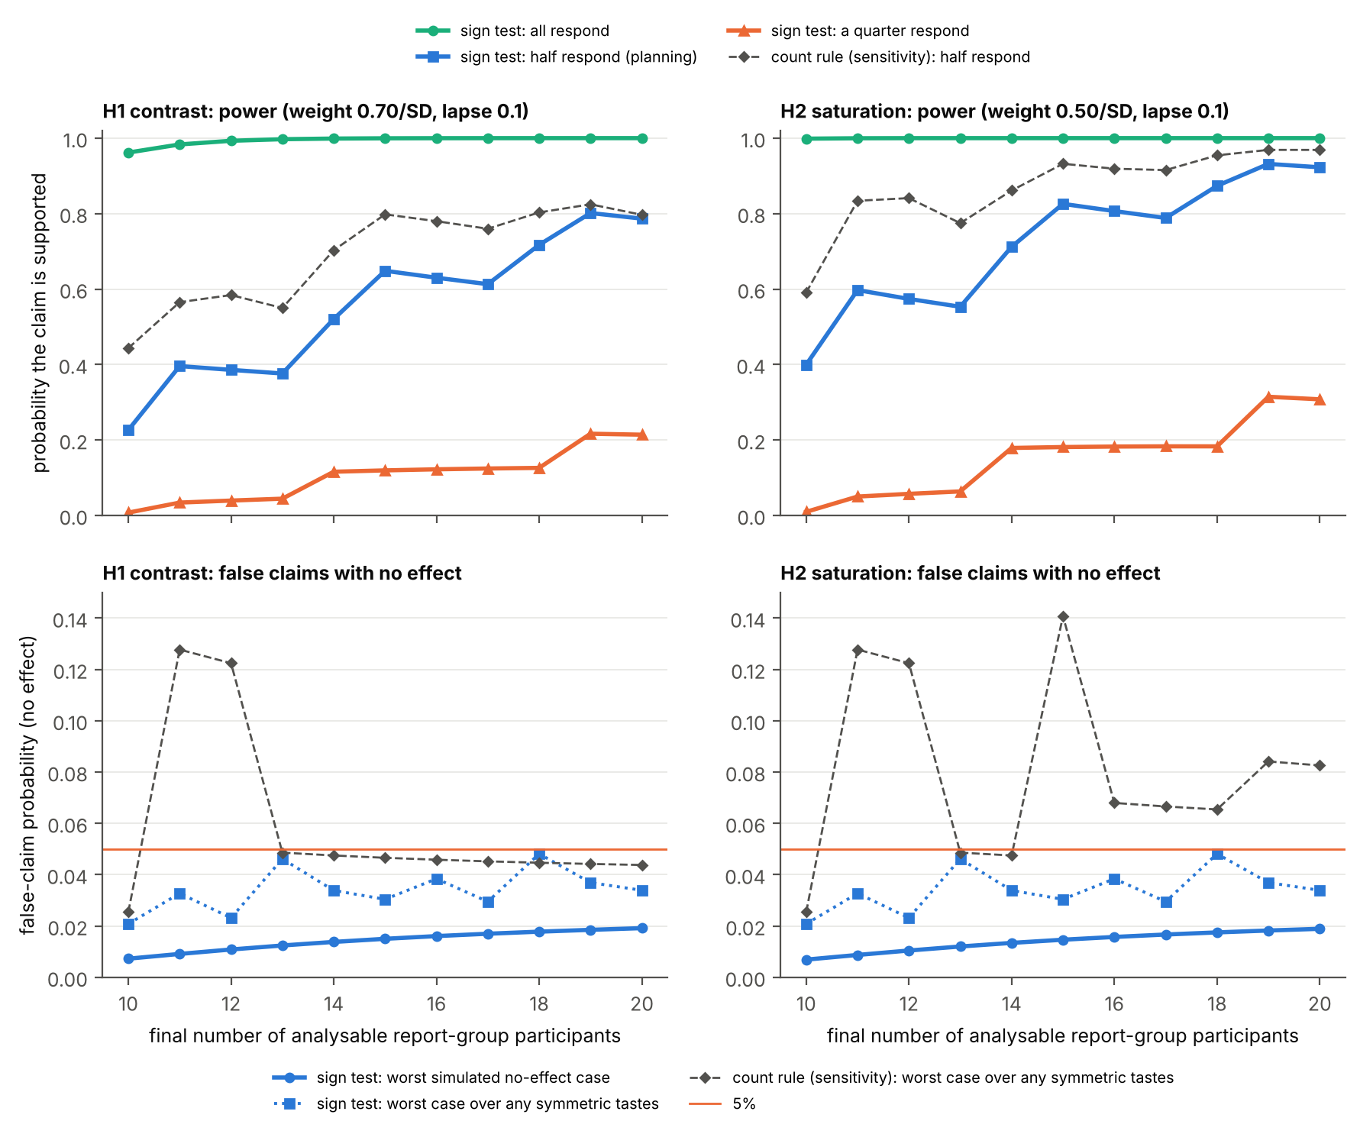
Figure 5. Estimated statistical power and false-positive probabilities for H1 (local contrast) and H2 (saturation), across the planned range of report-group sample sizes. Top: probability of supporting each hypothesis when all, half, or one-quarter of participants have a genuine feature-related preference. The dashed lines show the count-rule sensitivity analysis under the main planning scenario. Bottom: probability of incorrectly supporting each hypothesis under different assumptions about personal preferences unrelated to derealization, compared with the 5% significance threshold. The irregular changes across sample sizes reflect the discrete number of detected participants required by the decision rules.
C1 assesses whether feature-related preference weights are stronger in the report group than in the comparison group. Its power depends on the proportion of genuine responders and on preferences that might occur in both groups independently of episode recollection. To account for the latter possibility, the simulations included a strategy in which participants favour the more heavily edited-looking image. The main C1 planning scenario assumes that one-quarter of participants in each group use this strategy, half of the report group are genuine responders, and 10% of trials are answered randomly. With 30 comparison-group participants, estimated power increases from approximately 40% with ten report-group participants to 57% for local contrast and 61% for saturation with twenty (Figure 6). These simulations apply the attention check but not the catch-failure exclusion: every simulated participant completes the task and is analysed. In the study, participants with three or more catch failures are excluded (Section 2.7); because recruitment draws on a fixed pool, they cannot always be replaced, and the power at the final number of analysable participants applies.
To estimate false-positive rates, we simulated studies in which neither group had a genuine episode-related effect and recorded how often C1 was nevertheless supported. Across the simulated scenarios, approximately 2–3% of studies produced a significant result for each feature considered separately, while 3.5–4.6% produced a significant result for at least one of the two features. These percentages represent the proportion of simulated studies in which the analysis incorrectly supported C1. In additional scenarios where both groups shared a directional preference unrelated to derealization, the probability of supporting at least one C1 comparison was approximately 5%. These figures describe the specific assumptions examined and do not guarantee the same error rates under all possible circumstances.
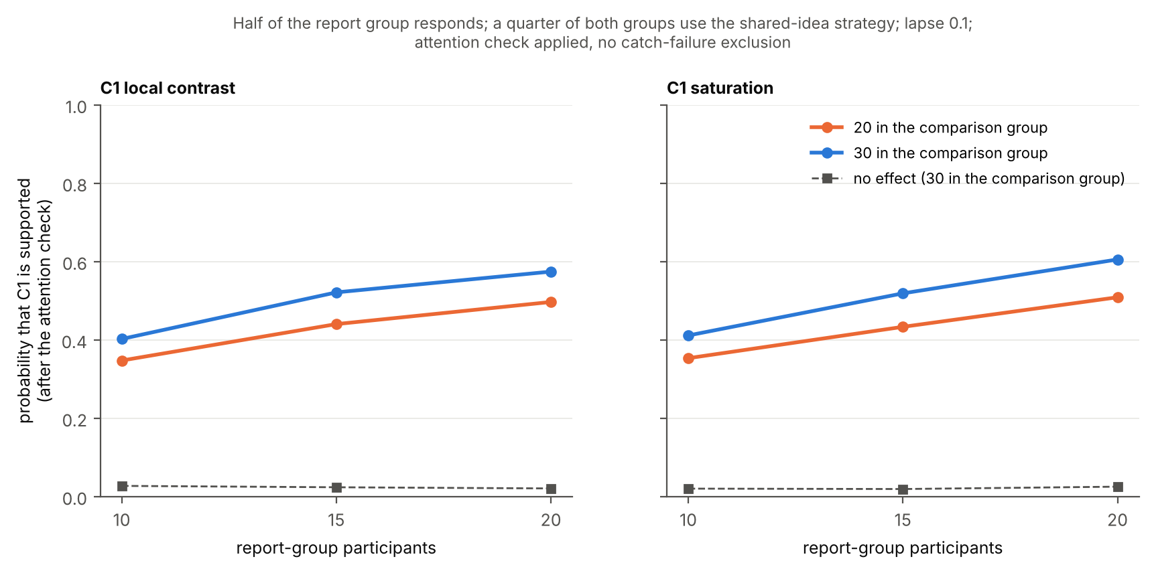
Figure 6. Estimated power for C1 by report-group sample size, with either 20 or 30 comparison-group participants. The planning scenario assumes that half of the report group have a genuine feature-related preference, one-quarter of each group favour the more heavily edited-looking image, and 10% of trials are answered randomly. The simulations apply the attention check, which classifies C1 as inconclusive when triggered, but not the catch-failure exclusion. Dashed lines show the probability of supporting C1 when no genuine group difference is present.
The simulations also evaluated the attention check described in Section 3.4. When both groups had similar levels of attention, the check was triggered in approximately 3.8% of simulated studies on average, making C1 inconclusive despite no underlying attention difference. In contrast, when the comparison group responded randomly more frequently, the attention check was triggered in nearly all studies under the examined scenarios. In these cases, C1 was classified as inconclusive rather than supported, preventing potential differences in attention from being interpreted as differences in feature preferences. These findings depend on the assumptions used in the simulations and do not guarantee the same performance with actual participants.

Supplementary material

S1. Why local contrast and saturation
The two experimental image features were selected before stimulus construction through a computational analysis connecting descriptions of derealization with measurable characteristics of photographs. The procedure comprised extraction of text-defined axes from literature descriptions (S1.1–S1.3), image and feature measurement (S1.4), analysis of associations between axes and features (S1.5), and validation, including a final-stimulus manipulation check (S1.6). Scripts and outputs are available in the project repository (Section 5.2).

S1.1 Phrases from the literature
Each of nine sources (Ciaunica et al., 2022; Dilkes, 2024; Fino et al., 2024; Miyazono, 2021; Pienkos & Sass, 2022; Radovic & Radovic, 2002; Sierra & Berrios, 2001; Simeon & Abugel, 2023; Tanaka, 2018) was provided separately to two large language models, Claude (Opus 5.5) and ChatGPT (GPT-5.6 Sol). A fixed prompt requested verbatim expressions describing how the world, objects, or other people looked or felt. To avoid steering the models towards particular expressions, the prompt contained no example of a derealization description. Extracted phrases were classified by speaker (e.g., patient or author), referent (surroundings, objects, or people), modality (vision, hearing, touch, another sense, or not sense-specific), and state (altered or ordinary). A script verified quotations against the source text after normalising letters and digits to accommodate line breaks and hyphenation. Unmatched quotations were excluded, near matches were reviewed manually, and the model outputs were merged, yielding 1,718 verified phrases and agreement measures for each label.

S1.2 Grouping into axes
Phrases describing an altered state through visual or unspecified sensory language were retained (1,140 distinct texts). Independently of sources and counts, each model grouped the phrases by a single named quality. The resulting groupings showed moderate agreement (adjusted Rand index = 0.70), and disagreements were resolved manually. Prespecified criteria required at least five texts from two documents, at least one first-person phrase, a coherent meaning, and a feature plausibly visible in a scene; 18 of 32 candidate groups met these criteria. We then selected ten groups for CLIP analysis using four criteria specified before inspection of CLIP results: the quality had to describe an image property rather than the observer, apply across scenes, be expressible in caption language, and not primarily represent a control dimension (image quality, mood, or threat).

S1.3 Captions and their negatives
Each phrase was converted into a grammatical caption using minimal edits to fit the form 'a scene that looks {caption}', preserving the original content words. Both models proposed captions; an automated procedure checked their wording and fluency, and discrepancies were reviewed manually. Each caption was paired with a matched negative describing ordinary appearance by changing only the one or two words expressing the target quality (e.g., foggy → clear; dull → vivid), without using syntactic negation. The final set comprised nine axes (Table S1) and 191 caption pairs.

Name | Pairs
unreal, fake, artificial | 33
dreamlike, in a dream | 25
movie, picture, film set | 11
simulation, video game | 21
veil, glass wall, barrier, bubble | 44
fog, blurry, hazy | 29
flat, two-dimensional | 6
dull, less vivid, colorless (vividless) | 10
lifeless, dead, empty | 12
Table S1. The nine axes and their numbers of caption pairs.

S1.4 Axes, image scores and image features
Each semantic axis was defined as the normalised mean difference between CLIP text embeddings of its positive and negative captions (ViT-L/14-336; Radford et al., 2021). Excluding Places365 photographs dominated by people, animals, or objects left 1,111,881 images in 332 scene categories (Zhou et al., 2018). Each image was encoded with un2CLIP using the same CLIP model, and the cosine similarity between its embedding and each semantic axis was standardised across the corpus. Twelve image features were used: local contrast, tonal entropy, spectral slope, global contrast, brightness, shadow level, saturation, saturation spread, yellowness, redness, hue variety, and illuminant colour. Black-and-white and toned images were flagged and excluded from the primary analyses.

S1.5 Links between axes and features
Because scene categories differ in both image features and semantic-axis scores, the analysis centred these variables within categories and regressed each axis score on all twelve features simultaneously (1,071,373 colour images; confidence intervals from 1,000 category-level bootstrap resamples). Both selected axes were associated with both features, but the relative associations were distinctive. Saturation was more strongly associated with vividless than fog (within-category β = −0.40 versus −0.30), while local contrast was more strongly associated with fog than vividless (β = −0.27 versus −0.19). This complementary pairing motivated the feature selection; choosing saturation for both axes would have relied on the same measured feature.

S1.6 Validation
- When six control axes (image quality, age, mood, threat, weather and greyscale) and the other eight axes are added as covariates, the links between the vividless axis and saturation (−0.19) and between the fog axis and local contrast (−0.15) both remain. When the closest axis (lifeless) is held constant, the vividless axis keeps its link with saturation and loses its link with local contrast.
- To validate the selected features, we applied individual image manipulations to 150 photographs not used in the experiment and measured how their CLIP axis scores changed relative to the original images. Reducing saturation primarily increased the vividless score (+1.59 corpus SD, compared with +0.55 for fog). The haze-like contrast reduction, with mean brightness restored to its original level, increased the fog score (+1.54 corpus SD), but also increased vividless (+1.29), partly because it reduced saturation.
- We then evaluated all 2,115 generated image versions (47 scenes × 45 versions) using the same CLIP axes (Figure S1). Lowering saturation primarily affected the vividless axis, whereas reducing local contrast affected both fog and vividless because it also reduced saturation. However, across the 180 analysed image pairs, measured saturation differences were more closely associated with vividless, and measured local-contrast differences with fog. The participant-choice analyses use these measured image features, not CLIP scores.
CLIP scores quantify changes in model-derived semantic concepts, not human visual judgements. Moreover, one reviewer made the manual decisions involved in axis construction, and inter-rater reliability was not assessed.
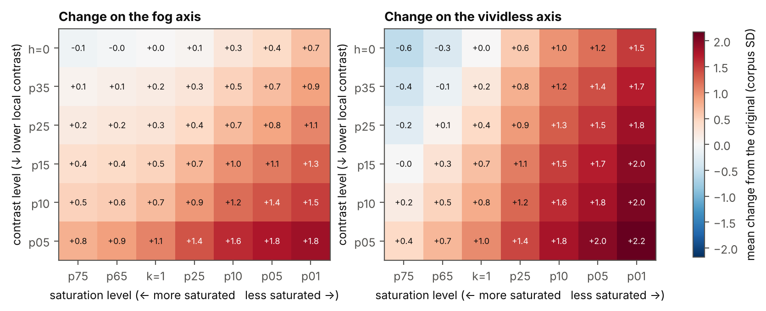
Figure S1. Manipulation check on the final stimuli. Mean change from each scene's unedited image on the fog axis (left) and the vividless axis (right), in corpus SD, for every saturation level (columns, from higher to lower saturation) and contrast level (rows, from the original down), averaged over the 47 scenes.

References [TO COMPLETE: Double-check references]
American Psychiatric Association. (2013). Diagnostic and statistical manual of mental disorders (5th ed.).
Ciaunica, A., Pienkos, E., Nakul, E., Madeira, L., & Farmer, H. (2022). Exploration of self- and world-experiences in depersonalization traits. Philosophical Psychology. https://doi.org/10.1080/09515089.2022.2056009
de Leeuw, J. R., Gilbert, R. A., & Luchterhandt, B. (2023). jsPsych: Enabling an open-source collaborative ecosystem of behavioral experiments. Journal of Open Source Software, 8(85), 5351.
Dilkes, J. (2024). Metaphor use in depersonalization/derealization. Language and Cognition, 16(2), 329–352. https://doi.org/10.1017/langcog.2023.39
Fino, E., Jemmett-Skinner, T., Evans-Miller, R., Perkins, J., Malik, M., Robinson, M., & Webb, G. (2024). Dispositional traits, characteristic adaptations, and narrative identity reconstructions in individuals with depersonalization and derealization. Journal of Personality.
Firth, D. (1993). Bias reduction of maximum likelihood estimates. Biometrika, 80(1), 27–38.
Holm, S. (1979). A simple sequentially rejective multiple test procedure. Scandinavian Journal of Statistics, 6(2), 65–70.
Hunter, E. C. M., Sierra, M., & David, A. S. (2004). The epidemiology of depersonalisation and derealisation: A systematic review. Social Psychiatry and Psychiatric Epidemiology, 39(1), 9–18. https://doi.org/10.1007/s00127-004-0701-4
Kusztor, A., Mulay, N., Yamada, M., Hohwy, J., & Tsuchiya, N. (2025). Lifting the veil: Probing altered visual perception in derealization. Neuroscience of Consciousness, 2025(1), niaf045. https://doi.org/10.1093/nc/niaf045
Miyazono, K. (2021). Visual experiences without presentational phenomenology. Ergo. https://doi.org/10.3998/ergo.1156
Pienkos, E., & Sass, L. (2022). "Robbed of my life": The felt loss of familiar and engaged presence in depersonalization/derealization disorder. Journal of Phenomenological Psychology, 53, 51–81. https://doi.org/10.1163/15691624-20221398
Radford, A., et al. (2021). Learning transferable visual models from natural language supervision. Proceedings of ICML.
Radovic, F., & Radovic, S. (2002). Feelings of unreality: A conceptual and phenomenological analysis of the language of depersonalization. Philosophy, Psychiatry, & Psychology, 9(3), 271–279. https://doi.org/10.1353/ppp.2003.0048
Rouder, J. N., Speckman, P. L., Sun, D., Morey, R. D., & Iverson, G. (2009). Bayesian t tests for accepting and rejecting the null hypothesis. Psychonomic Bulletin & Review, 16(2), 225–237.
Sierra, M., & Berrios, G. E. (2000). The Cambridge Depersonalisation Scale: A new instrument for the measurement of depersonalisation. Psychiatry Research, 93(2), 153–164.
Sierra, M., & Berrios, G. E. (2001). The phenomenological stability of depersonalization: Comparing the old with the new. The Journal of Nervous and Mental Disease, 189(9), 629–636.
Sierra, M., Baker, D., Medford, N., & David, A. S. (2005). Unpacking the depersonalization syndrome: An exploratory factor analysis on the Cambridge Depersonalization Scale. Psychological Medicine, 35(10), 1523–1532.
Simeon, D., & Abugel, J. (2023). Feeling unreal: Depersonalization and the loss of the self (2nd ed.). Oxford University Press.
Sugiura, M., Hirosawa, M., Tanaka, S., Nishi, Y., Yamada, Y., & Mizuno, M. (2009). Reliability and validity of a Japanese version of the Cambridge Depersonalization Scale as a screening instrument for depersonalization disorder. Psychiatry and Clinical Neurosciences, 63(3), 314–321. [to verify: journal details]
Suzuki, K., Seth, A. K., & Schwartzman, D. J. (2024). Modelling phenomenological differences in aetiologically distinct visual hallucinations using deep neural networks. Frontiers in Human Neuroscience, 17, 1159821. https://doi.org/10.3389/fnhum.2023.1159821
Tanaka, S. (2018). What is it like to be disconnected from the body? A phenomenological account of disembodiment in depersonalization/derealization disorder. Journal of Consciousness Studies, 25(5–6), 239–262.
Yokokawa, K., Ito, T., Takahata, K., Takano, H., Kimura, Y., Ichise, M., Ikoma, Y., Isato, A., Zhang, M.-R., & Kawamura, K. (2018). Neuromolecular basis of faded perception associated with unreality experience. Scientific Reports, 8(1), 8062. https://doi.org/10.1038/s41598-018-26382-9
Zhou, B., Lapedriza, A., Khosla, A., Oliva, A., & Torralba, A. (2018). Places: A 10 million image database for scene recognition. IEEE Transactions on Pattern Analysis and Machine Intelligence, 40(6), 1452–1464.

TODO:
- Roca-Vila et al. (2013), cited in 2.4 for the gamma-matching task and still marked “[to verify reference]”.
- un2CLIP, used in S1.4 and named only in the [TO COMPLETE] note under References

